XK02 -

Functionality
Most of the fields in Vendor Master can be changed. The only restriction is your authorization in the system.

Scenario
You’ve received information from your bank that the outgoing payment couldn’t be sent to a vendor because his account number was incorrect. You need to change this vendor master.

Requirements

Vendor Master

Menu Path | Accounting → Financial Accounting → Accounts Payable → Master records → Maintain centrally → XK02 - Change
Transaction Code | XK02

1. Double click on XK02 - Change

Change Vendor: Initial Screen

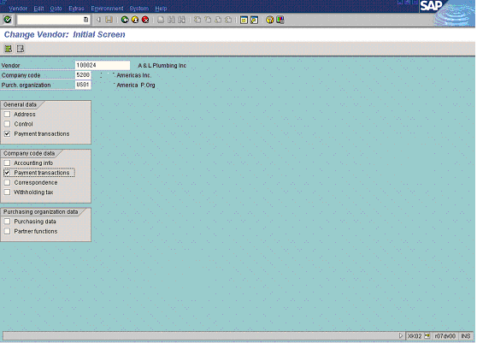

2. Update the following fields:

Field Name | Field Description | Values
Vendor | Enter vendor number here | Example: 100024
Company code | Code identifying a separate legal entity for which a separate set of accounts is maintained for external reporting purposes | Example: 5200
Purch. organization | Organizational unit within Logistics, subdividing an enterprise according to the requirements of Purchasing | Example: US01

3. Now you need choose which areas you want to change. Let’s assume you want to change payment transactions data and accounting data. Click Payment transactions and Accounting info radio buttons.

4. Click Enter Button to confirm your entries. The system now will display a sequence of screen, according to previously entered criteria:

Change Vendor: Payment transactions

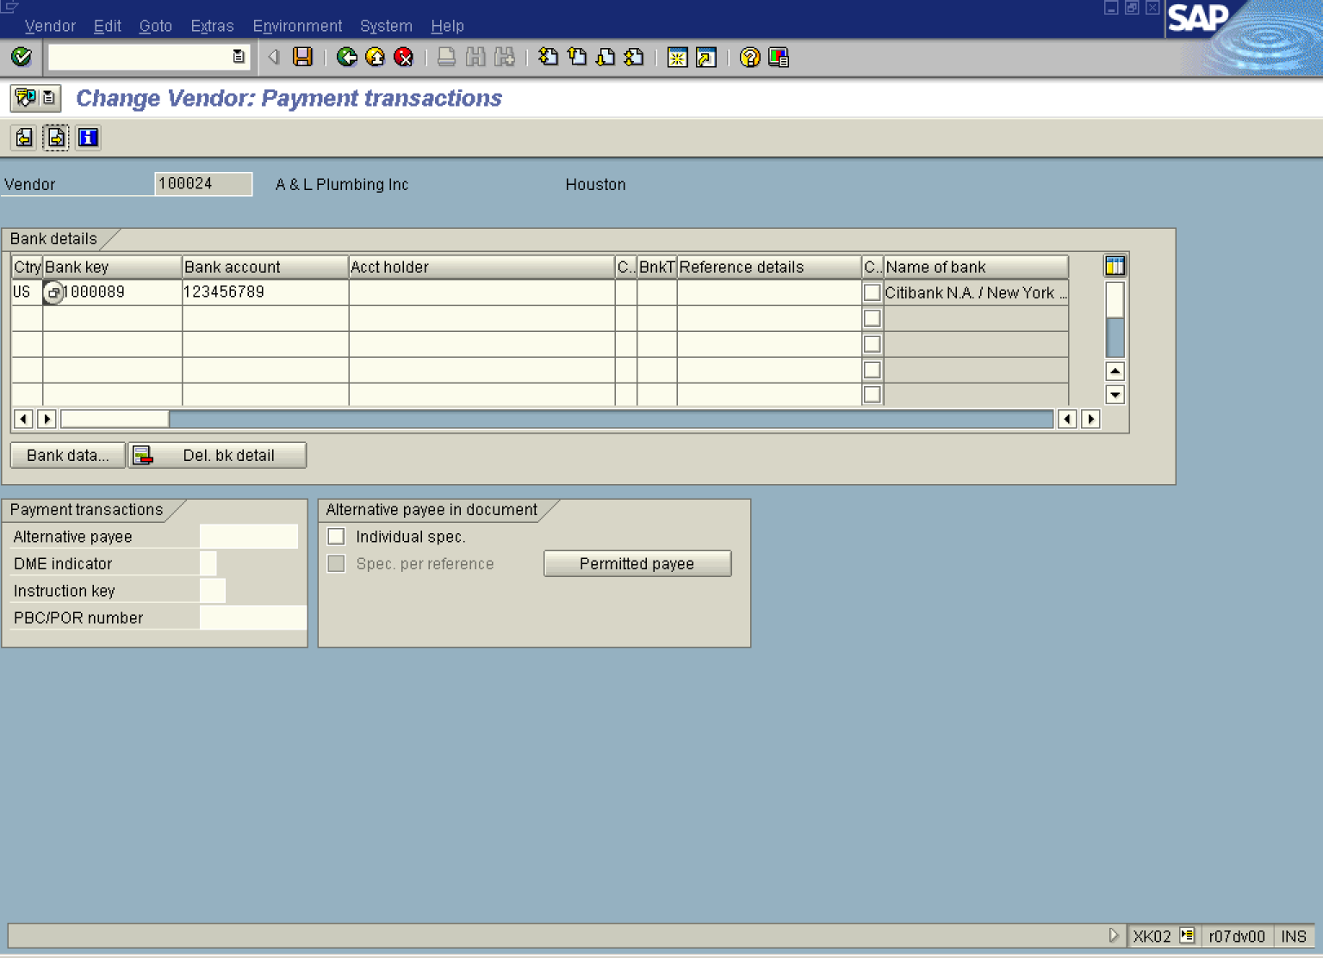

5. Update the following fields:

Field Name | Field Description | Values
Bank account | Bank account number | Example: 123456789

6. Click Next Button .

Change Vendor: Payment transactions Accounting

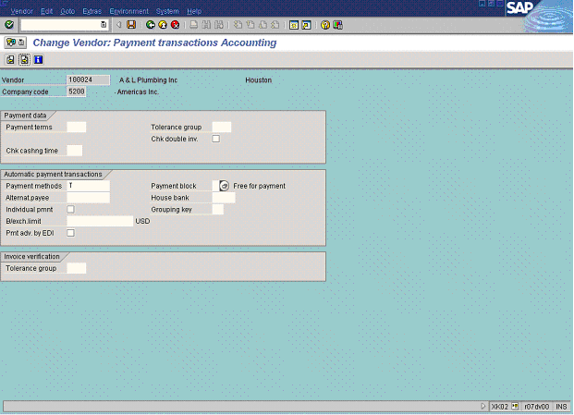

7. Update the following fields:

Field Name | Field Description | Values
Payment methods | Code of payment method. It is used to perform automatic outgoing payment. | Example: T

8. Click Next Button . The system will ask you to save your changes:

Last data screen reached

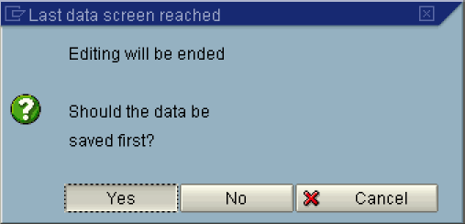

9. Click Yes .

10. The message bar displays “Changes have been made”.

